**Project Name: Blue Waters**

**Name: Parveez Ali**

**Database systems-CPSC-50900-005**

**ID: L30062935**

**Assignment: Week 3**

**GitHub link:** [**https://github.com/aliparvez12/Bluewaters.git**](https://github.com/aliparvez12/Bluewaters.git)

**Current Date:11/16/2022**

**ERD Model Part 3:-**

**1.) Crate an ERD using UML this must be a physical model.**

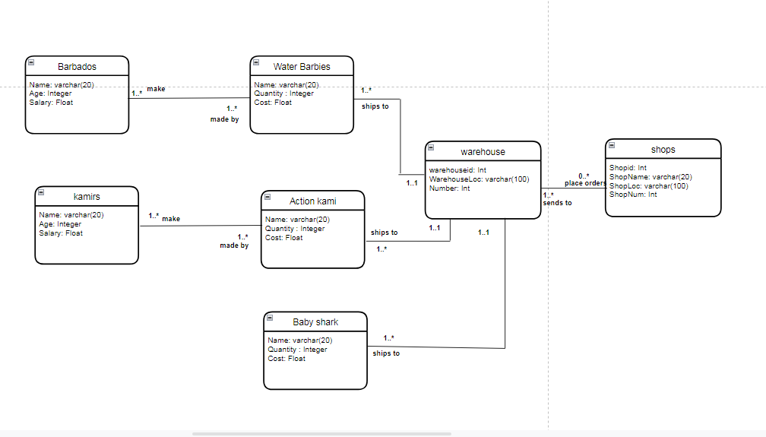

**2.) Create a second ERD using Crow’s foot notation. This will be logical model.**

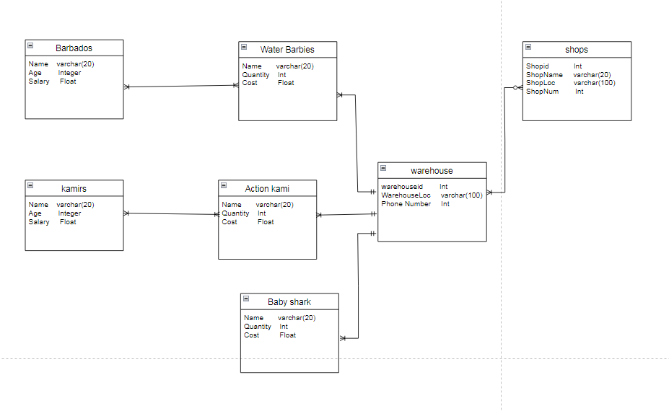

**3.) Finally write a description of the relationship. Using the time/sales/store/product example for week 2, you might write.**

**Sales depends on 1 and only 1 time entity, 1 or zero store (online sale), and 1 or many products write a similar description for every line in your drawing. 4 lines=4 relationship statements.**

**Be sure you address all arrows in your drawing like the example does with descriptions like ‘1or’ 1 and …’,’0 or more**

* Barbados entity has one or more (1..*) relation with Water Barbies as they can make at least one or more Barbie products.
* Kamirs entity has one or more (1..*) relation with Action kami as they make at least one or more action kamie products.
* Baby shark entity has one or more (1..*) relation with warehouse entity and warehouse had one and only relation with baby shark entity.
* Action kami entity has one or more (1..*) relation with kamirs because one or more products are made by kamirs.
* Warehouse entity has one or more (1..*) relation with shops as it sends at least one or many products to shops and receives zero or more(0..*) orders from shops.